**Purple Team: Dylan Bonis, Robert Duvall, Melinda Guthman, Meg Kellenberger** :

12/4/22, Module 10 Assignment, Willson Financial

**Revised ERD:**

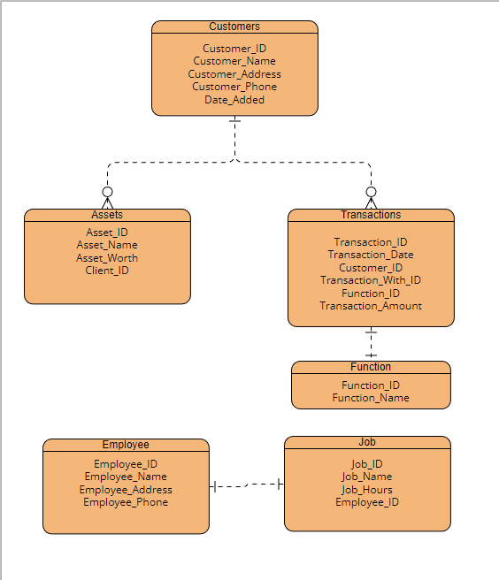

**Changelog:**

12/1/22

Added Transaction_ID

Added_Transaction Type

Changed Customer to Client to better fit prompt

Added Employee_Address and Employee_Phone

Removed Employee and Job? (Though they are still part of the database for function)

12/2/22

Changed Transaction Type to Function Table w/ Function ID and Function_Name

Changed Client to Customer due to it being a reserved word

Added Date_Added to Customer table

**3NF:**

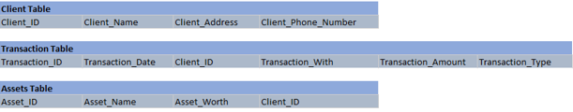

**Display Screenshots:**

